# Installing gcloud cli

 [Refer Here](https://cloud.google.com/sdk/docs/install) for the docs to install gcloud cli

 [Refer Here](https://cloud.google.com/sdk/docs/initializing) for initialization or setting up gcloud cli

# Google Cloud Networking

 The most important component of network architecture in the GCP is Virtual Private Cloud

 VPC networks are globbal resources i.e. a single vpc can span multiple regions without communicating over public internet

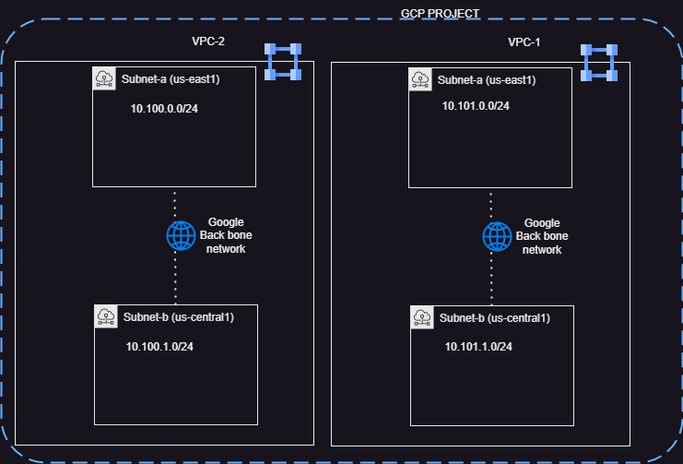

 VPC networks do not define IP address ranges, Instead each VPC Network is comprised of one or more partitions called subnets and each subnet defines one or more IP ranges

 Subnet are regional resources